Client Analysis
In order to define scope and functionality, information from the client is gathered to understand the goals and expectations of the client. Having the client answer a series of structured questions helps the client to think critically and clearly define goals and expectations.
Goal of this web project
- In two or three sentences, what is the goal or purpose of this website?
The current site is very outdated. It is very plain and has
- What is your USP (Unique Selling Point).
They are a warehouse business that sells hydraulic seals, parts kits, and other materials to help manufacturing businesses succeed. The unique selling point for me is that fact that their site is very plain and outdated. A refresh could really help facilitate business.
- What information will visitors want to see first?
The majority of visitors would be customers of VB Seals. For this reason I think contact information and product information would be key.

Questions that help define the project
- Do you have a web presence now? If so, what do you want to keep and what do you want to change? Do you have any sites that you would like to emulate? What do you like about them?
They have a site currently that is very plain. They do not have much of web presence at the moment. The goal is for customers that might search for VB Seals to find a professional looking website.
- What will make this site a success? Hits? Publicity? Revenue?
The site will be a success with a good looking product. They will not use the site for direct sales but having an attractive site would not hurt anything.
- What type of content will be on the site? Does this content already exist?
Products, services, and contact information will be the main focus of the site. Some of this already exists. Some will need to be provided.

- What items will be included in the site: Blog, e-commerce, feedback forms, registration forms, user submissions, etc.
The site will be informational with a contact page. There will not be any forums or user login.
- Will you want to update the site yourself? If so, how many different people will be updating the site? If you will NOT update the site yourself, how often will it need to be updated?
I will update the site myself. It would most likely be only me making changes. It should not need to be updated more than a few times a year.
- What are the categories (major groupings) of information that will be on every page?
Products, Services, and contact information
10. Will this information likely be accessed by mobile devices?
It is unlikely that the site would have heavy mobile traffic.

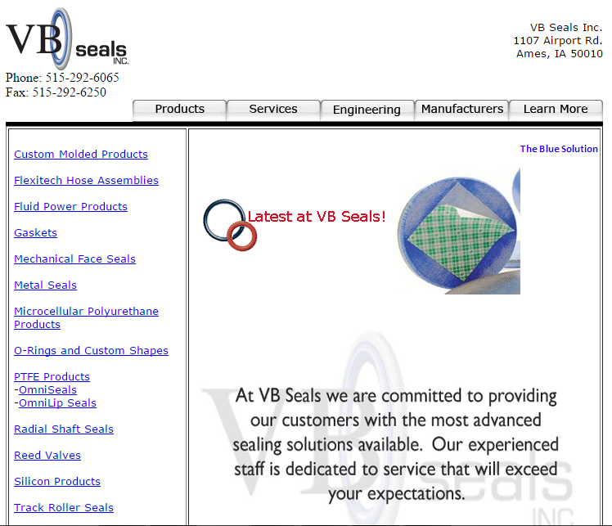
The current site.
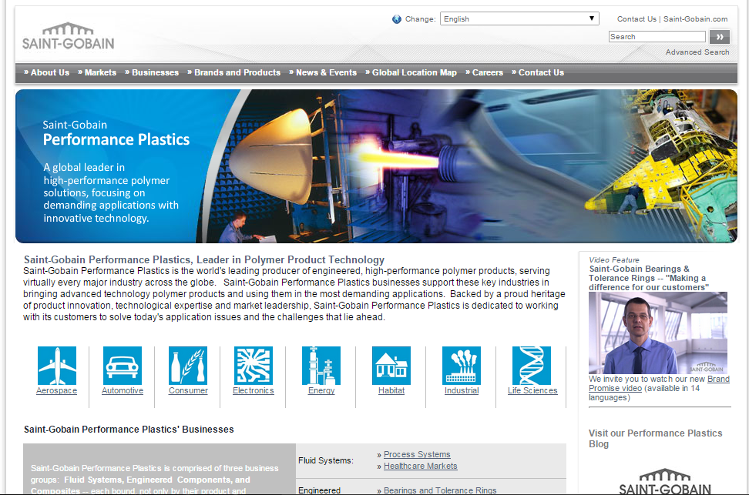
This is a screen shot of a site to emulate. This is a site of a manufacturer that VB Seals gets parts from. They have a centered site with some images on the main page and a center navigation page at the top.

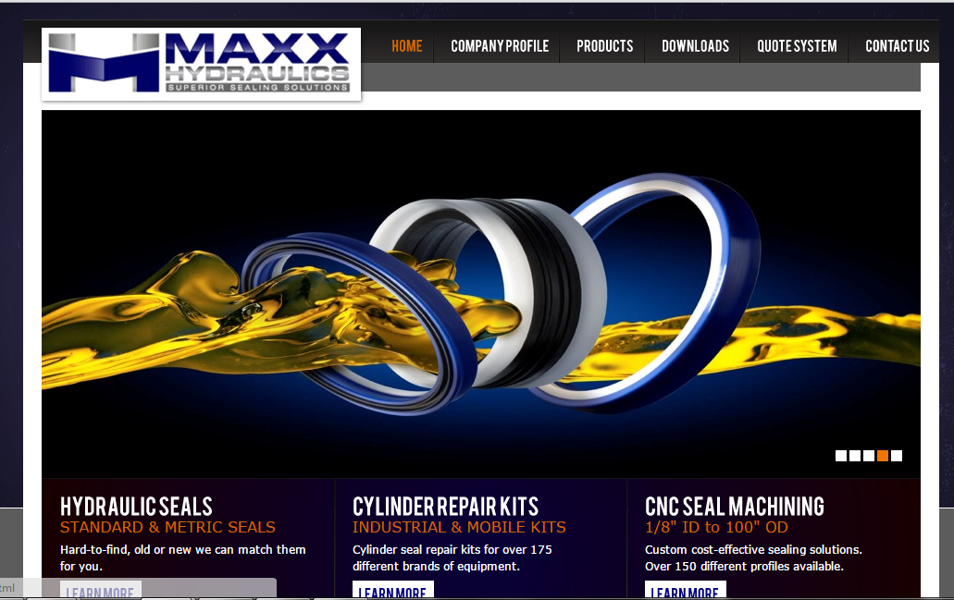
This is a screen shot of a site that sells hydraulic seals. They have a similar style of a centered webpage with navigation at the top and a large image rotator. I would like to have an image rotation on the main screen.

