Client Analysis
For
VB Seals
Prepared by
Matt Hall
02-15-2015

Proposal: Website redesign
Purpose: The purpose of this site is to provide information about VB Seals to visitors. The majority of visitors would be customers and prospective customers looking to gather more information about products or contact information of VB Seals.

Company Background: VB Seals is a warehouse business that sells hydraulic seals, parts kits, and other materials to help manufacturing businesses succeed.

Current Web Presence: VB Seals currently has a site at http://www.VBSeals.com. The current site is functional but is in need of a upgrade. It uses older technology and has not been updated in many years.

One site to emulate could be http://www.maxxhyd.com/. This site was found with a web search. Another site to emulate would be http://www.plastics.saint-gobain.com/. They are a supplier of parts for VB Seals.

- What will make this site a success? Hits? Publicity? Revenue?
The site will be a success with a good looking product. They will not use the site for direct sales but having an attractive site would not hurt anything.
- What type of content will be on the site? Does this content already exist?
Products, services, and contact information will be the main focus of the site. Some of this already exists. Some will need to be provided.
The redesigned site will have
- Home – exists
- Products - exists
- Services - exists
- Materials - new
- Engineering - exists
- Contact Us – exists in a Learn More area

- What items will be included in the site: Blog, e-commerce, feedback forms, registration forms, user submissions, etc.
The site will be informational with a contact page. There will not be any forums or user login.
- Will you want to update the site yourself? If so, how many different people will be updating the site? If you will NOT update the site yourself, how often will it need to be updated?
I will update the site myself. It would most likely be only me making changes. It should not need to be updated more than a few times a year.
- What are the categories (major groupings) of information that will be on every page?
Products, Services, and contact information
- Will this information likely be accessed by mobile devices?
It is unlikely that the site would have heavy mobile traffic.

Site Research
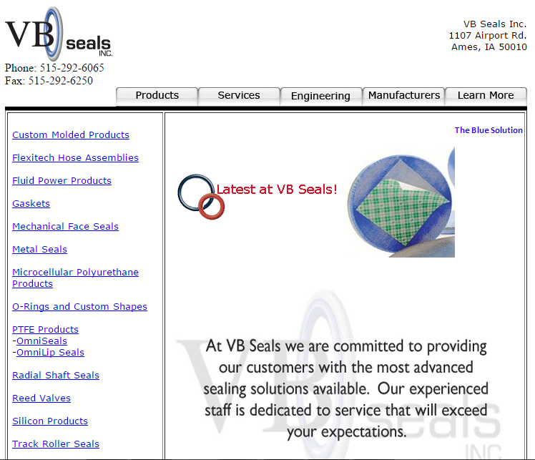
This is a screen show of the current site.
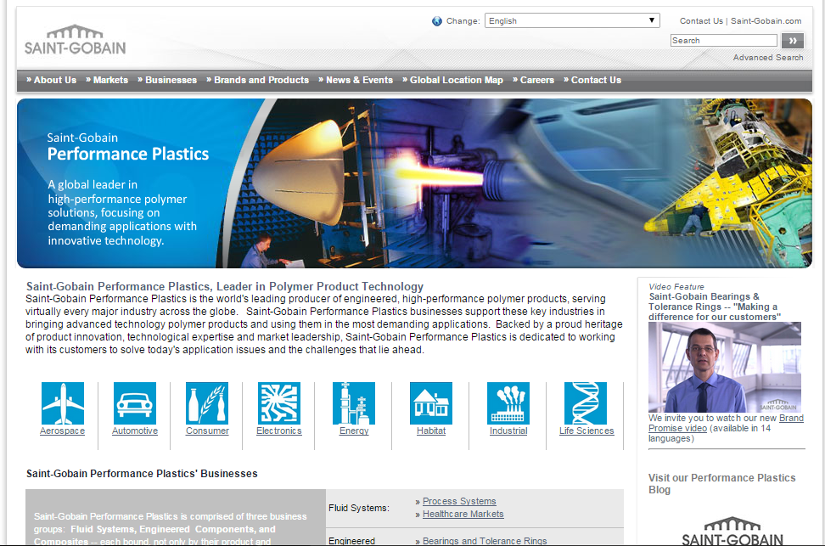
This is a screen shot of a site to emulate. This is a site of a manufacturer that VB Seals gets parts from. They have a centered site with some images on the main page and a center navigation page at the top.

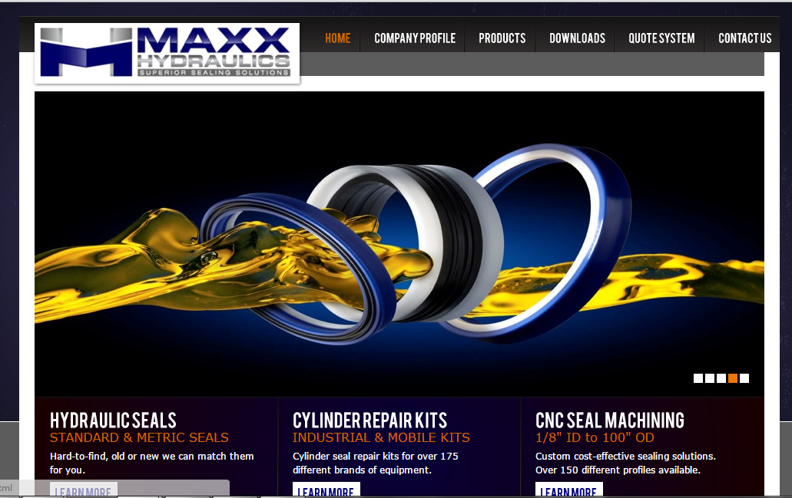
This is a screen shot of a site that sells hydraulic seals. They have a similar style of a centered webpage with navigation at the top and a large image rotator. I would like to have an image rotation on the main screen.

Site Map
The site will have a main page with a navigation bar centered below the header section. The navigation will have a drop down menu when the main navigation item is active. This is the general idea for the navigation.
Home | Products | Services | Materials | Engineering | Contact Us
 | Seals | All Services | Metals
 | Gaskets | Customer Service | Plastics
 | Packings | Search | Elastomers
 | Bearings
 | Brake Pucks

Method of Execution
This will be a custom built site with HTML/CSS. Most of the HTML/CSS will be done by hand in Notepad ++ and Dreamweaver. Some of the image manipulation will be done in Photoshop and Fireworks. I have Adobe CS5 with all of the needed applications on my person laptop.

