Symmetrical

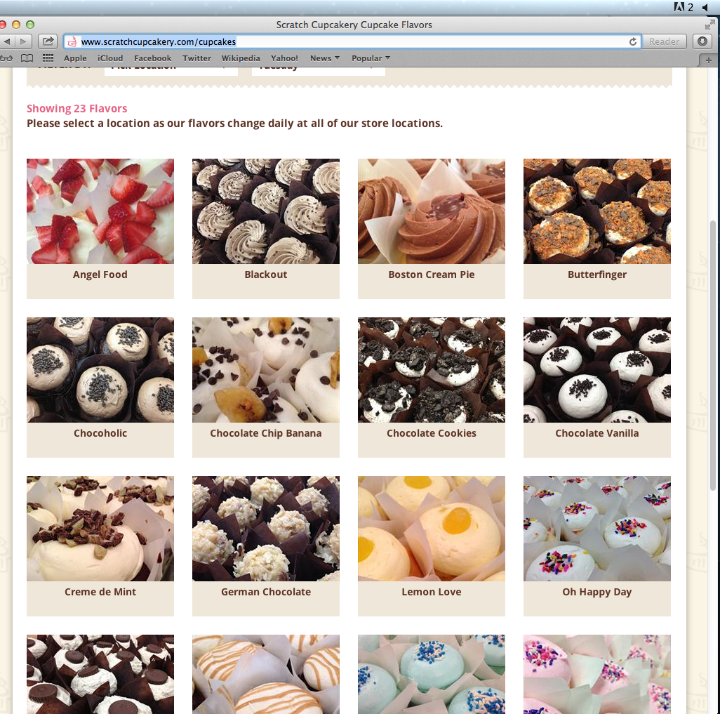
This is balanced with a grid of images. Splitting it down the middle would have 2 on each side. http://www.scratchcupcakery.com/cupcakes

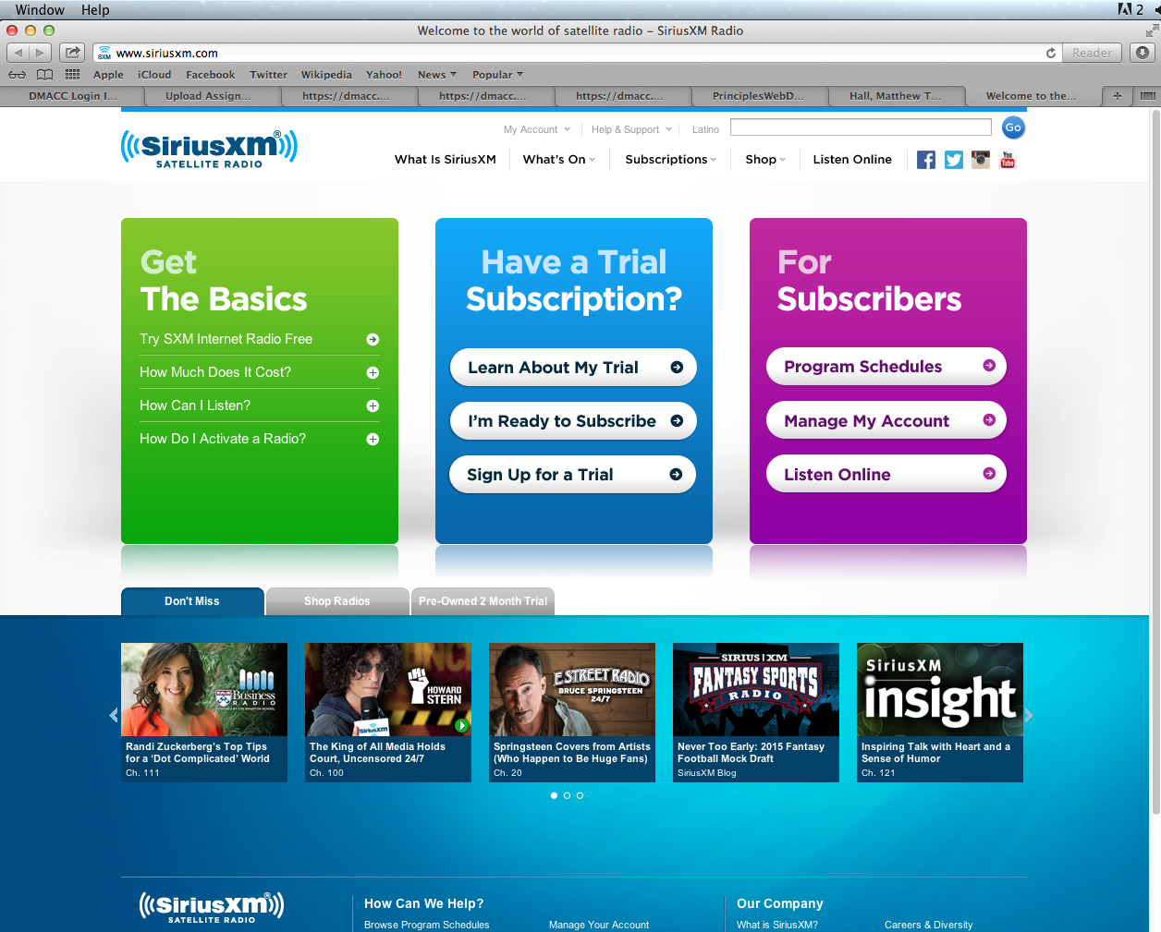
Even though there are 3 boxes it balances with the middle box split down the middle.
http://www.siriusxm.com

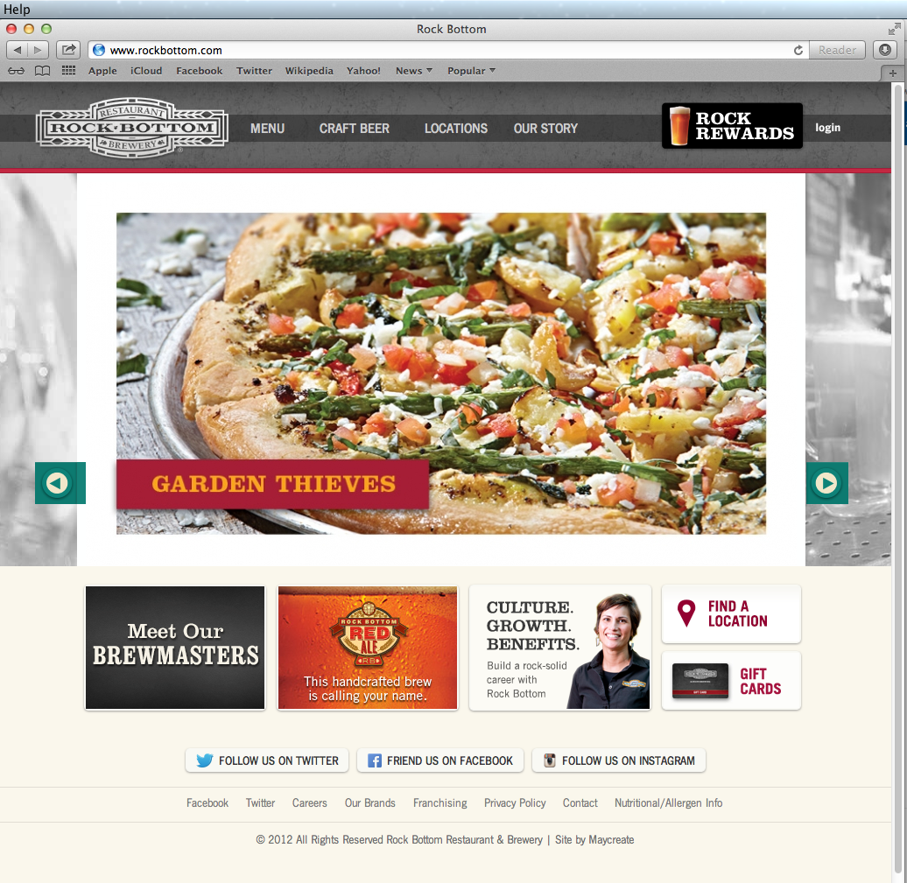
Different image sizes but it balances well. www.rockbottom.com

Asymmetrical
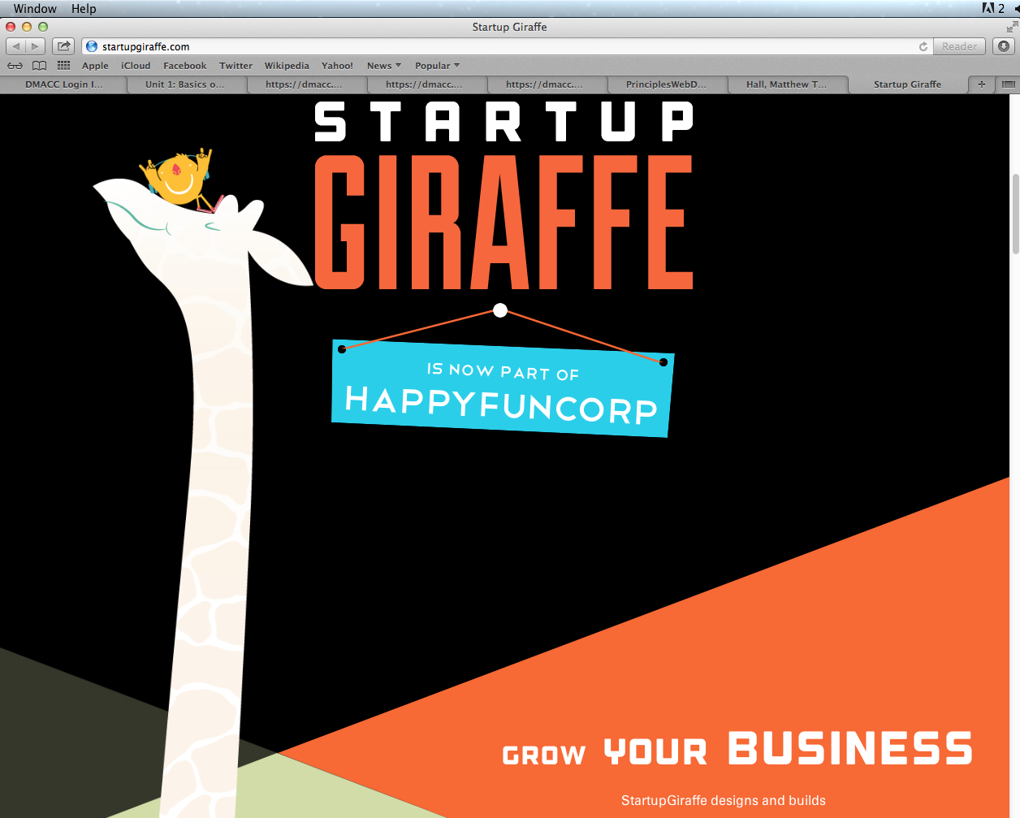
You have to scroll to get the full effect but it’s not symmetric but looks really good as it goes. The changes of color and size balance it out. www.startupgiraffe.com

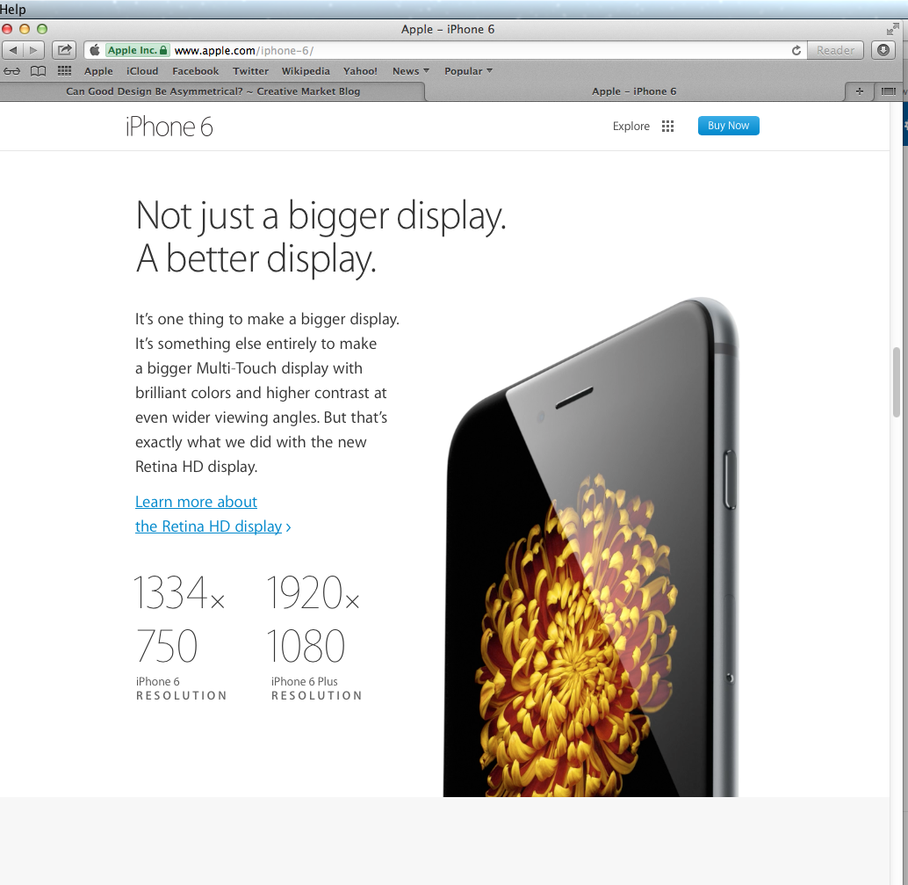
The phone image is big and off to the side and dark and the specks are smaller and light to give balance. www.apple.com/iphone-6/

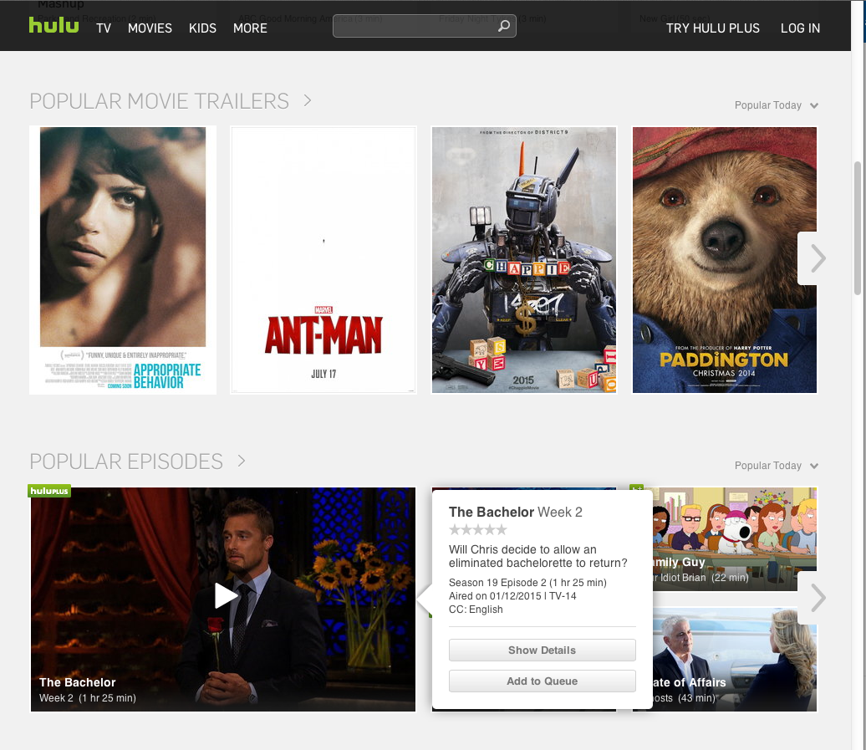
The different movies have different size boxes but they work out as different colors help balance it with the large dark image and a smaller white text box. www.hulu.com

