Identify Site Color Schemes

Monochromatic
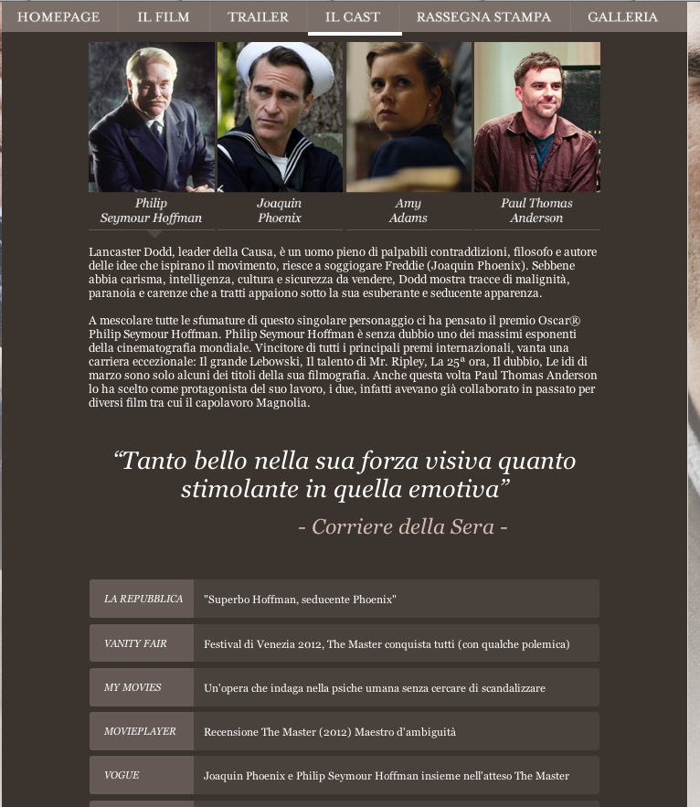
http://www.themasterilfilm.it

Analogous


Using Green Blue and Purple
http://www.siriusxm.com/

Split Complimentary

http://www.gatorzone.com

