Identify sites that use line, texture & patterns

One that utilizes lines extensively as design components
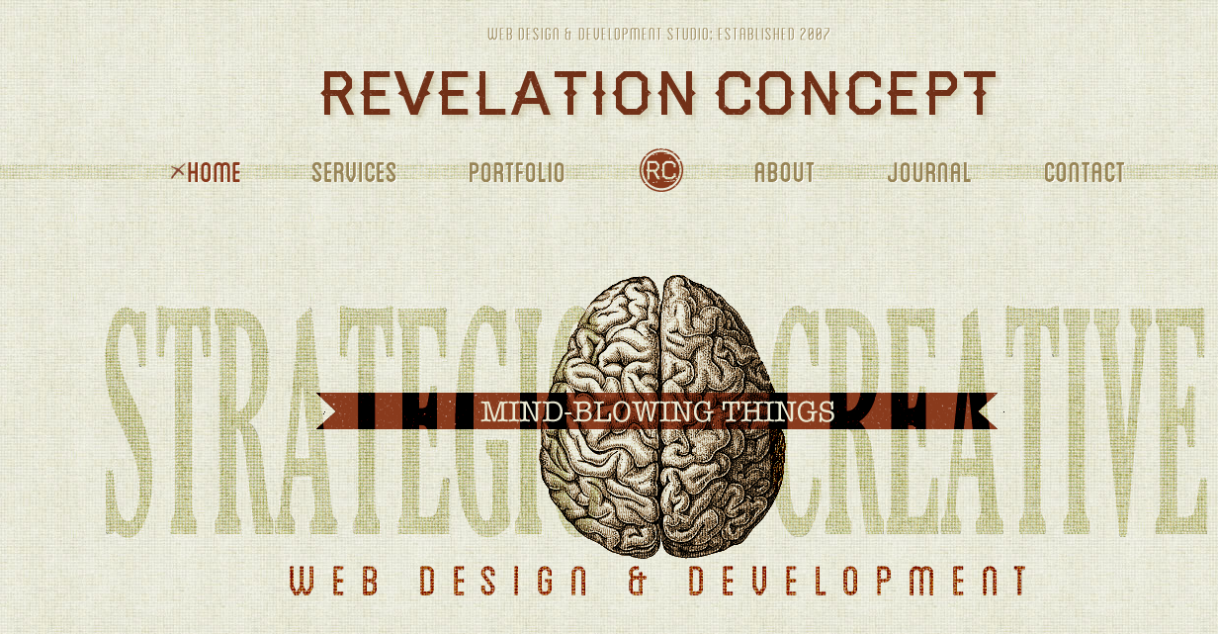
http://revelationconcept.com/

One that utilizes a texture in the page design
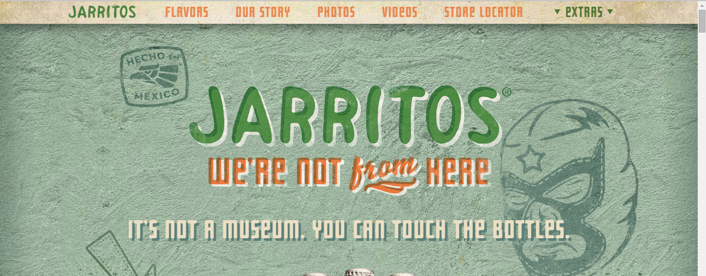

http://www.jarritos.com/

One that utilizes a repeating pattern
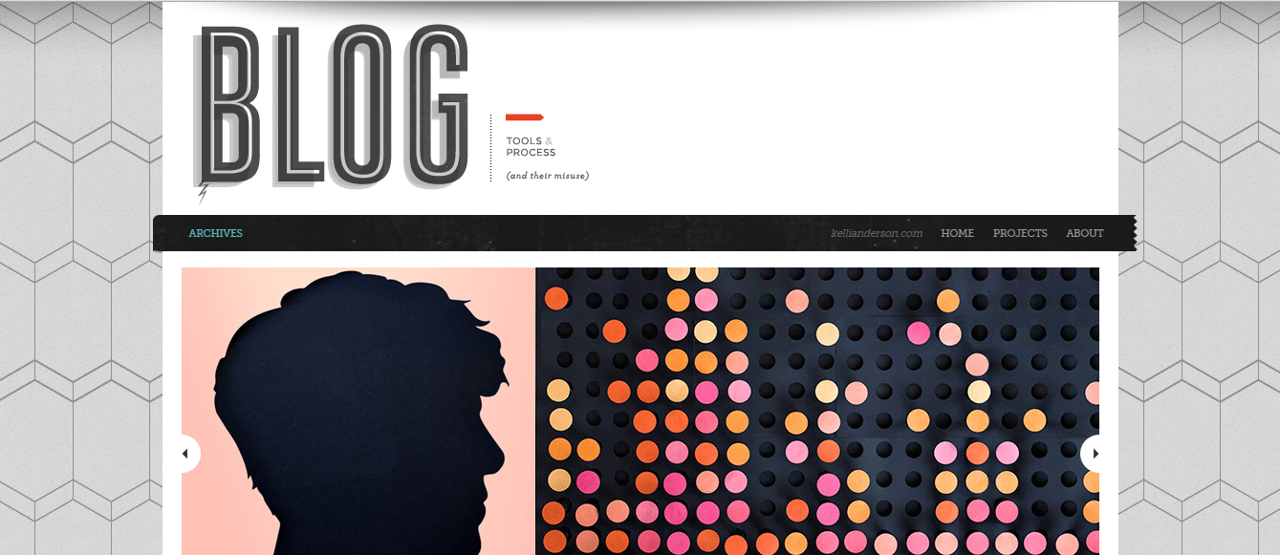
http://kellianderson.com/blog/

